EXP: 1.1
Transformation between Cartesian, Cylindrical and spherical coordinate system
PROGRAM:
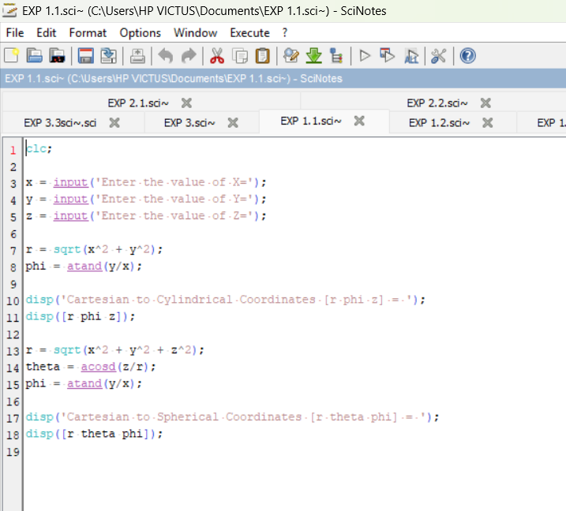
OUTPUT:
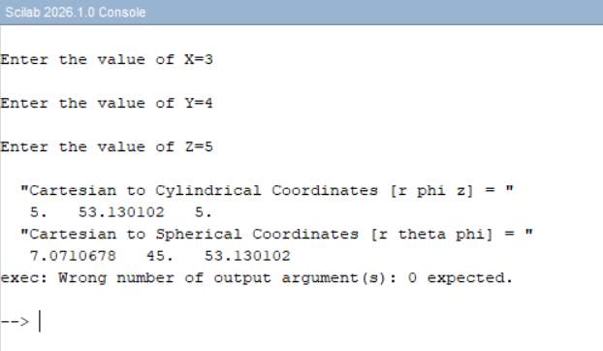
CALCULATION:
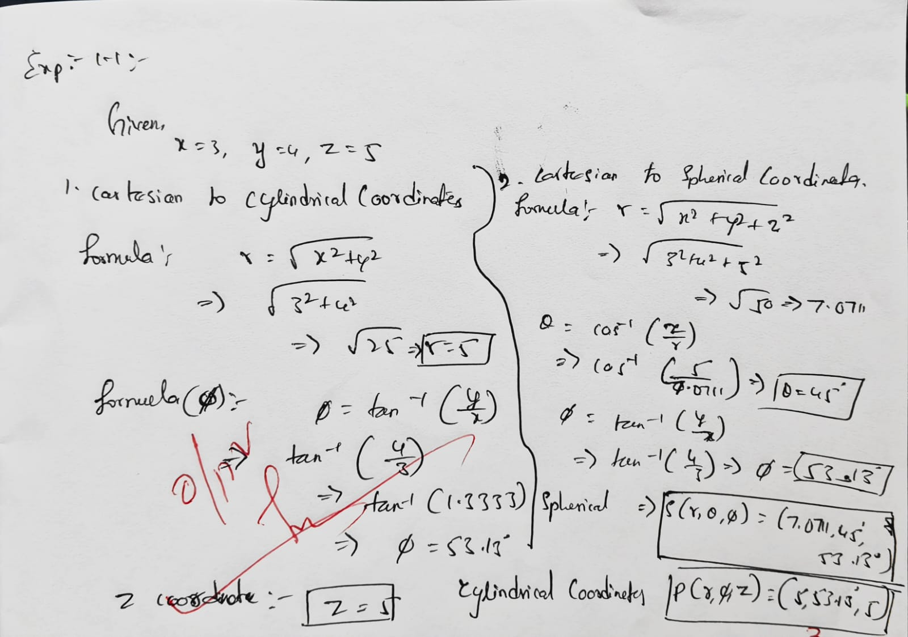

EXP: 1.2: Transformation of Cylindrical coordinate points into Cartesian and spherical
coordinate system
PROGRAM:
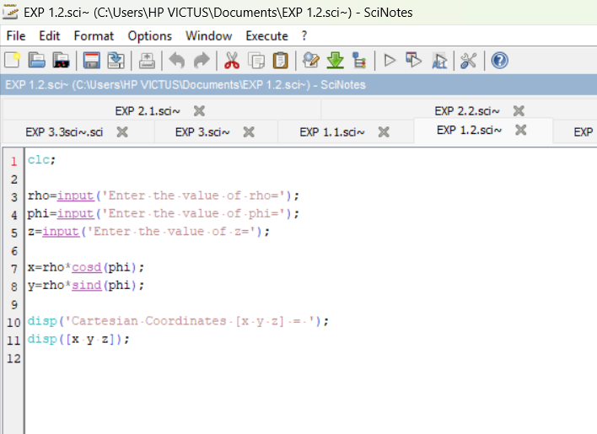

OUTPUT:
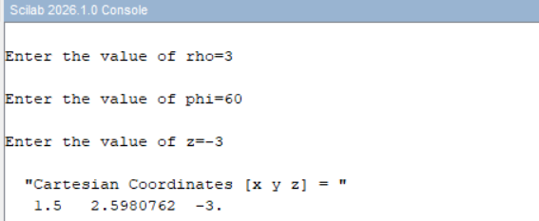
CALCULATION: 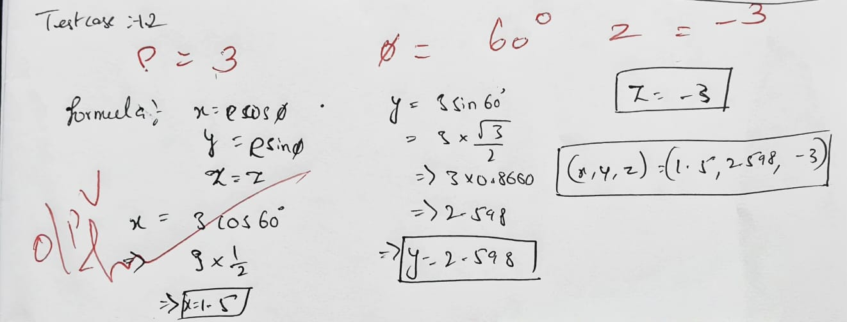

EXP 1.3: Transformation of spherical coordinate points into Cylindrical and Cartesian coordinate system
PROGRAM:
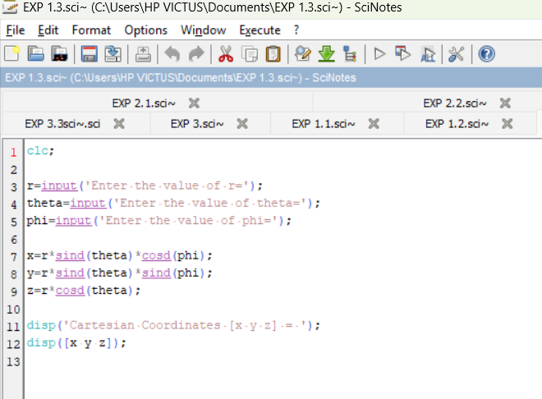
OUTPUT:
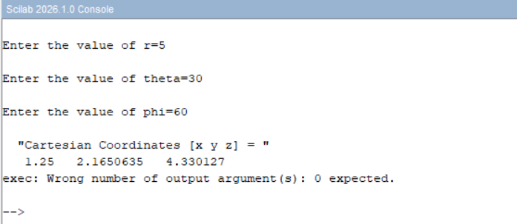
CALCULATION:
